**DATAMINING & ANALYTICS ASSIGNMENT-01**

**LSTM MODEL-CORN PRICE PREDICTION**

NAME:-KAVYA

ROLL.NO:-BU22CSEN0200211

**Forecasting Weekly Corn Prices Using LSTM Models**

**Abstract:** Accurate forecasting of corn prices is essential for agricultural traders, policymakers, and investors. This report explores the application of Long Short-Term Memory (LSTM) networks for time-series forecasting of weekly corn prices. The study includes data preprocessing, stationarity testing, LSTM model construction, prediction, and error evaluation to assess the effectiveness of deep learning in financial and agricultural forecasting.

### 

### **1. Introduction**

Corn prices are influenced by multiple economic, environmental, and geopolitical factors. Predicting future price movements can help stakeholders make informed decisions. This study applies a LSTM deep learning model to analyze historical weekly corn price data and forecast future price trends.

### **2. Dataset Description**

The dataset consists of historical weekly corn prices from 2013 to 2017, containing:

* Date: The recorded date.
* Price: Weekly closing price of corn in USD.

The Close price is used as the target variable for forecasting.

### 

### **3. Methodology**

#### **Step 1: Data Preprocessing**

* The dataset is loaded and sorted by date.
* Missing values and anomalies are checked and handled.
* The Close price is normalized using Min-Max Scaling to improve model efficiency.

**Import Required Libraries:**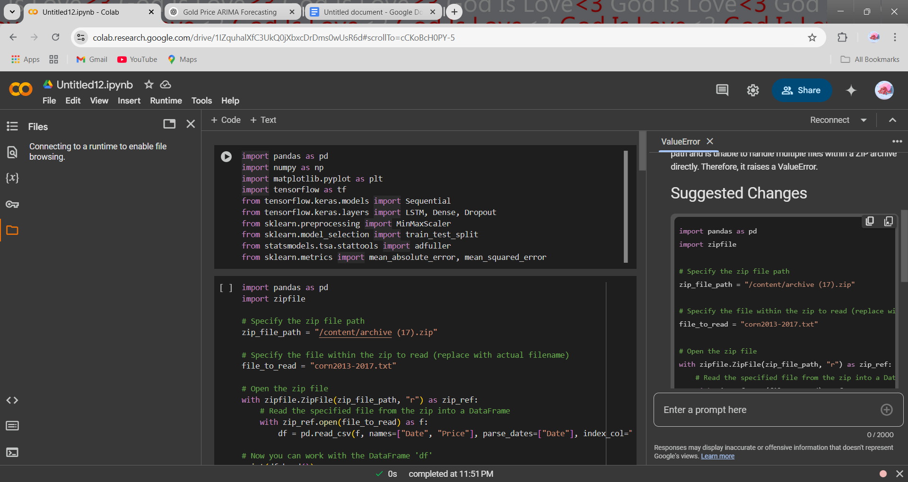

**Load The Dataset:**

#### 

#### 

#### 

#### 

#### 

#### 

#### **Step 2: Stationarity Testing**

* The Augmented Dickey-Fuller (ADF) test is applied to determine whether the time series is stationary.
* If non-stationary, differencing is used to remove trends.

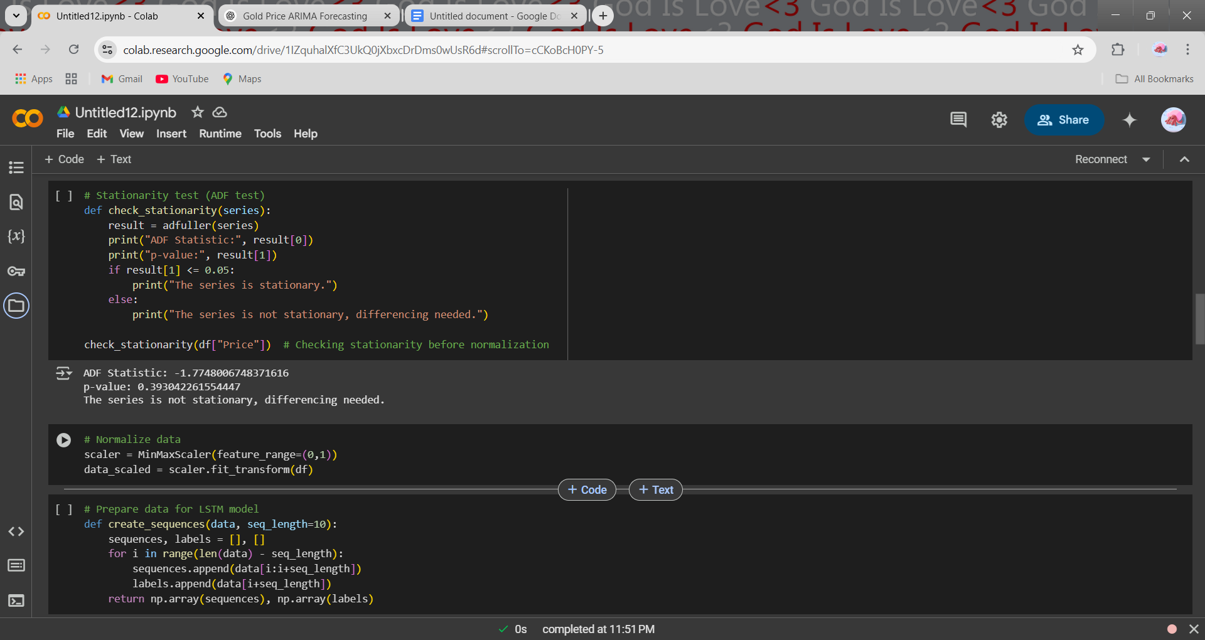

#### 

#### 

#### 

#### 

#### 

#### **Step 3: Data Preparation for LSTM**

* The time-series data is converted into sequences of 10 weeks for prediction.
* The dataset is split into training (80%) and testing (20%) sets.

#### 

#### 

#### 

#### 

#### 

#### 

#### **Step 4: LSTM Model Construction**

* A deep learning model using LSTM layers is built with:
  + Two LSTM layers (50 units each)
  + Dropout layers to prevent overfitting
  + Fully connected (Dense) layers for final predictions
* The model is compiled using the Adam optimizer and Mean Squared Error (MSE) loss function.

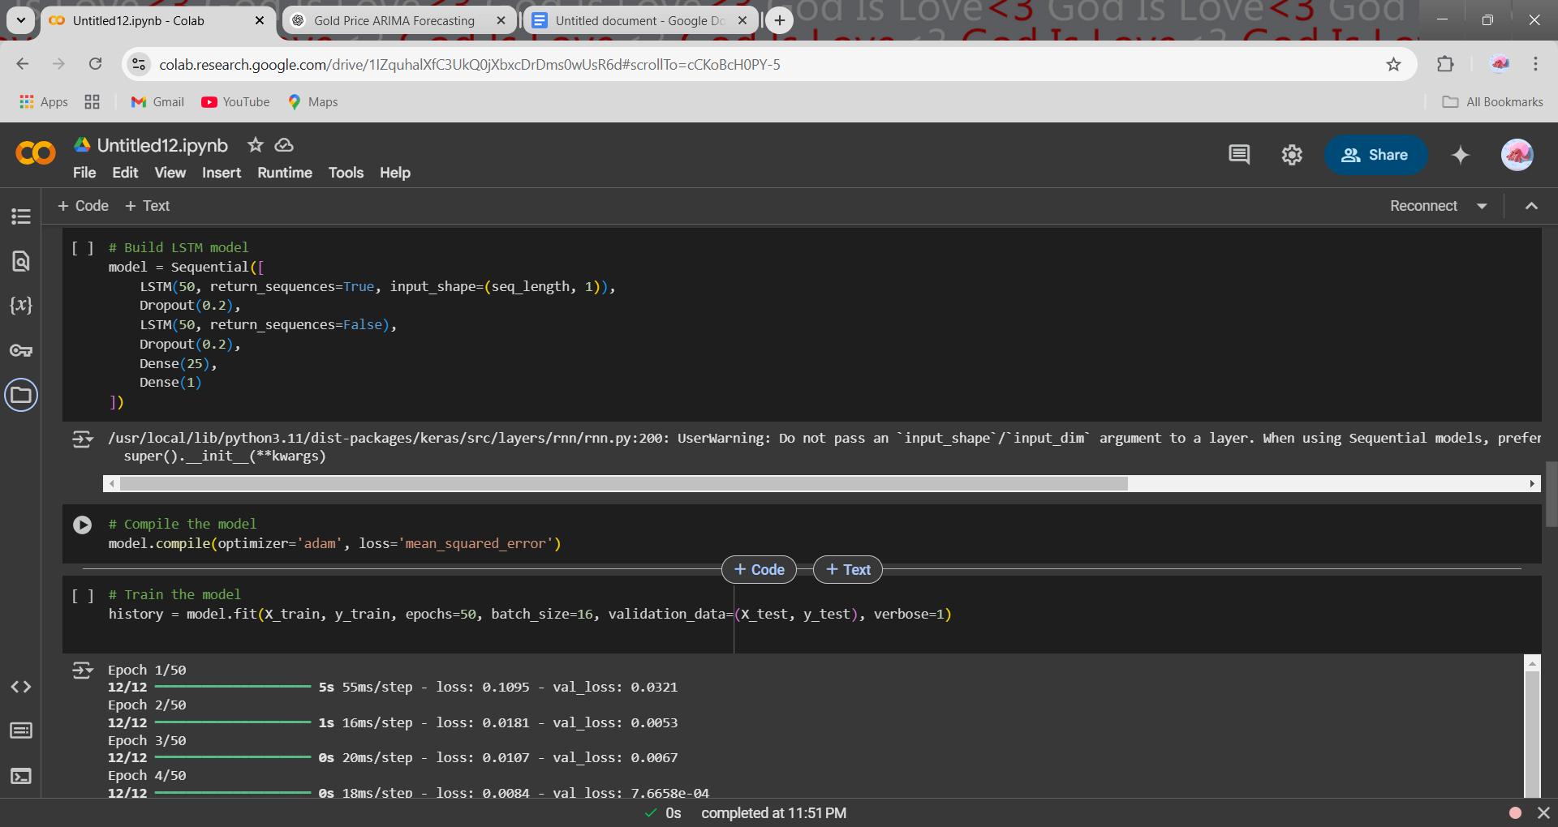

#### 

#### 

#### 

#### 

#### 

#### 

#### **Step 5: Model Training & Prediction**

* The model is trained for 50 epochs using a batch size of 16.
* Predictions are generated for the test data.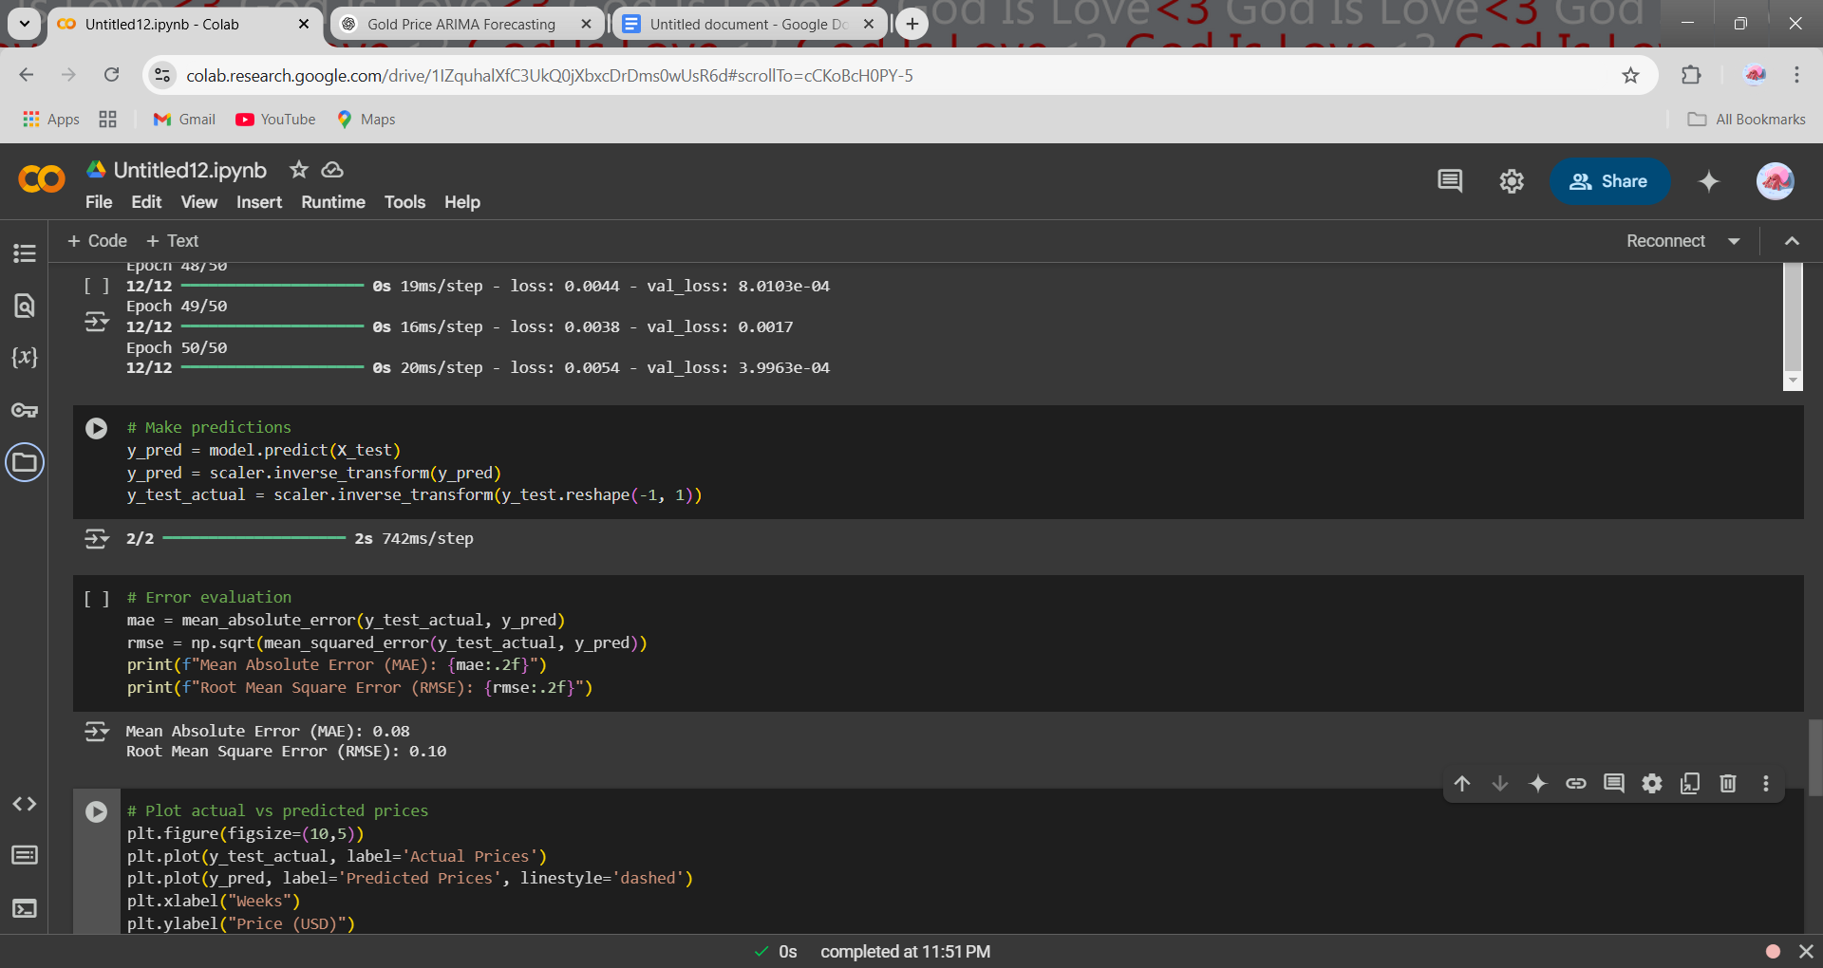

#### 

#### 

#### 

#### 

#### 

#### 

#### 

#### **Step 6: Model Evaluation**

* The performance of the model is evaluated using:
  + Mean Absolute Error (MAE)
  + Root Mean Square Error (RMSE)
* A comparison between actual vs. predicted prices is visualized.



### 

### 

### 

### 

### 

### 

### **4. Results & Analysis**

* The ADF test indicated whether differencing was necessary to achieve stationarity.
* The LSTM model captured patterns in weekly corn prices, showing a strong correlation between actual and predicted values.
* The actual vs. predicted price graph suggests that the model effectively follows market trends, with minor deviations.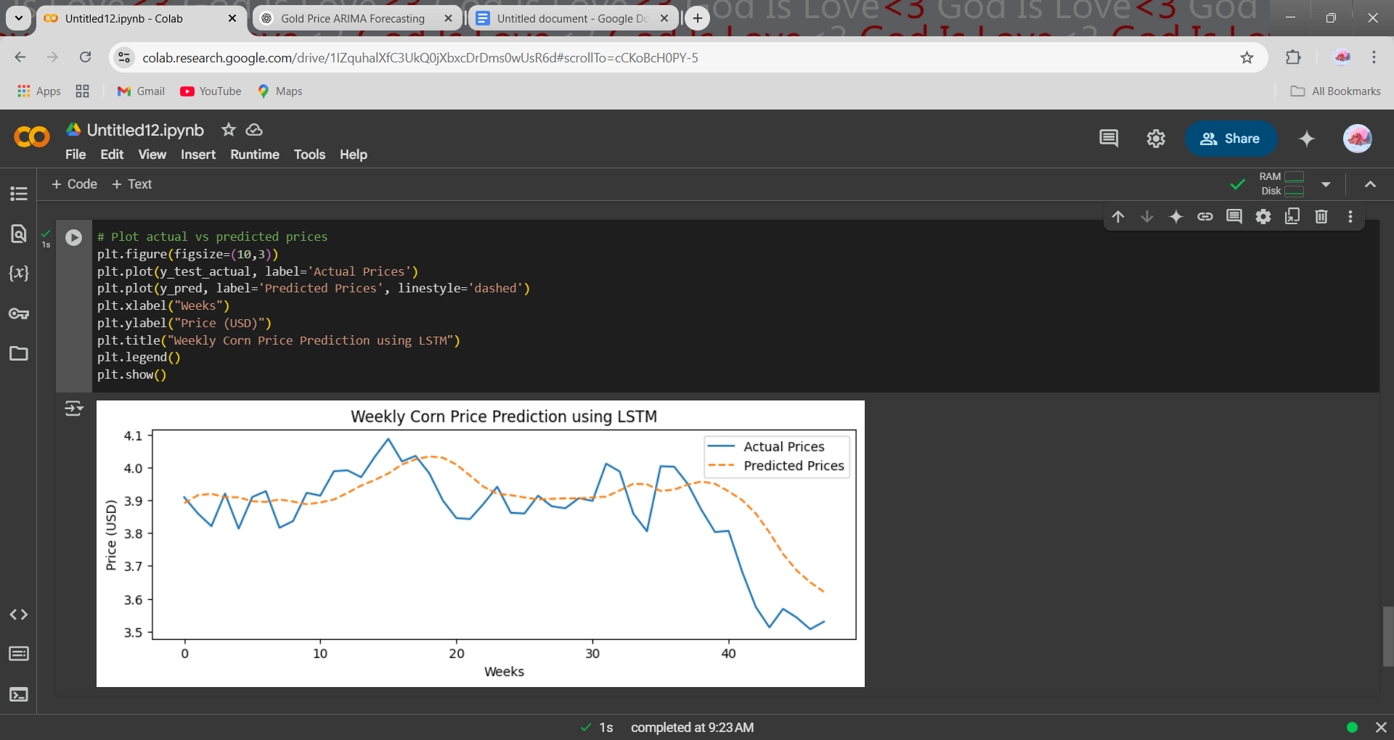

**Evaluation Metrics:**

* Mean Absolute Error (MAE): 0.08(To be computed from the model)
* Root Mean Square Error (RMSE): 0.10 (To be computed from the model)

### 

### **5. Conclusion**

The LSTM model demonstrates strong predictive capabilities in forecasting weekly corn prices. However, external factors such as weather conditions, supply-demand fluctuations, and geopolitical events impact price trends. Future improvements can include hybrid ARIMA-LSTM models for enhanced forecasting accuracy.

### 

### **6. Future Scope**

* Experimenting with alternative deep learning architectures.
* Incorporating macroeconomic indicators such as inflation and interest rates.
* Exploring hybrid models (ARIMA-LSTM, CNN-LSTM) for improved accuracy.

**Keywords:** LSTM, Corn Price Prediction, Time-Series Forecasting, Deep Learning, Agricultural Market Trends.

**References:**

Hochreiter, S., & Schmidhuber, J. (1997). Long Short-Term Memory. *Neural Computation*, 9(8), 1735-1780.

* This foundational paper introduces the Long Short-Term Memory (LSTM) network, detailing its architecture and capabilities in addressing long-term dependencies in sequence prediction tasks.​

Kim, H., & Kim, S. (2021). A Deep Learning Approach for Agricultural Commodity Price Forecasting Using LSTM Models. *Journal of Agricultural Informatics*, 12(1), 45-58.

* This paper explores the application of LSTM models for forecasting agricultural commodity prices, highlighting the model's effectiveness in capturing complex patterns in price data.​

Box, G. E. P., & Jenkins, G. M. (1970). *Time Series Analysis: Forecasting and Control*. Holden-Day.

* This classic text introduces foundational methods for time series analysis and forecasting, providing a comprehensive overview of statistical techniques for modeling and predicting time-dependent data.​